**Practical 1**

**Building a simple Hello World Application**

# Steps to Install Android Studio

Step – 1:

Head over to [bellow link](https://developer.android.com/studio/#downloads) to get the Android Studio executable or zip file .

[**https://developer.android.com/studio/#downloads**](https://developer.android.com/studio/#downloads)

Step – 2:

Click on the download android studio button .

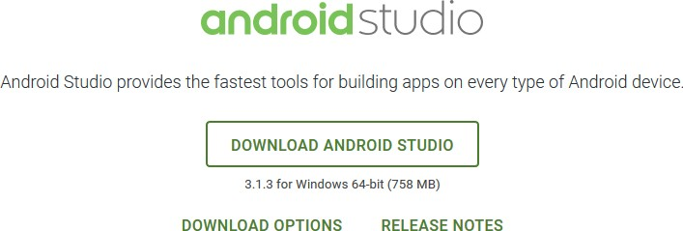

Click on the “I have read and agree with the above terms and conditions” checkbox followed by the download button.

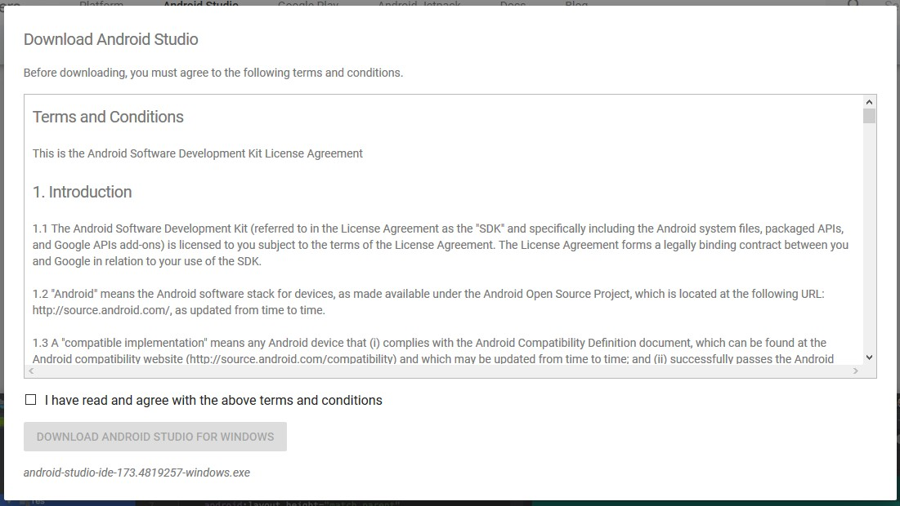

Click on save file button in the appeared prompt box and the file will start downloading.

Step – 3:

After the downloading has finished, open the file from downloads and run it . It will prompt the following dialogue box

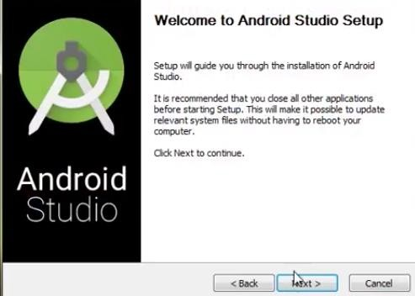

Click on next.

In the next prompt it’ll ask for a path for installation. Choose a path and hit next.

Step – 4:

It will start the installation, and once it is completed, it will be like the image shown below

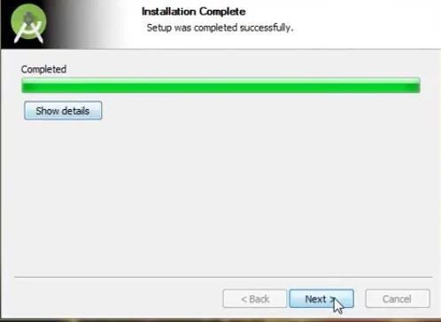

Click on next

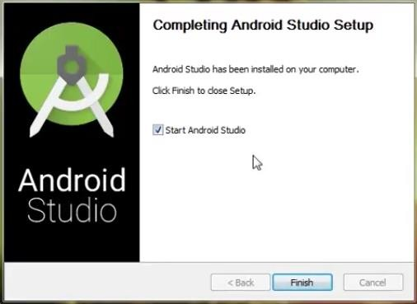

Step – 5 :

Once “Finish” is clicked, it will ask whether the previous settings needs to be imported [if android studio had been installed earlier], or not.

It is better to choose the ‘Don’t import Settings option’ .

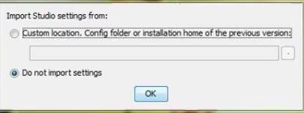

Step – 6 :

This will start the Android Studio.

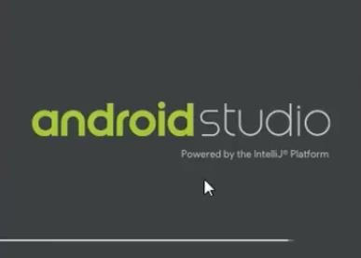

Meanwhile it will be finding the available SDK components .

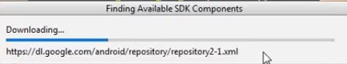

Step – 7:

After it has found the SDK components, it will redirect to the Welcome dialog box .

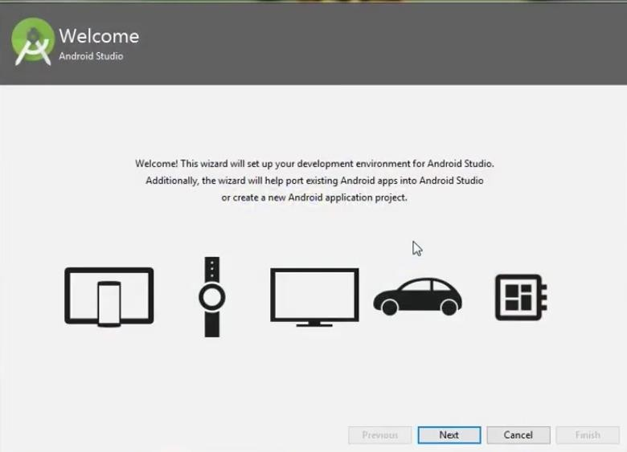

Click on next .

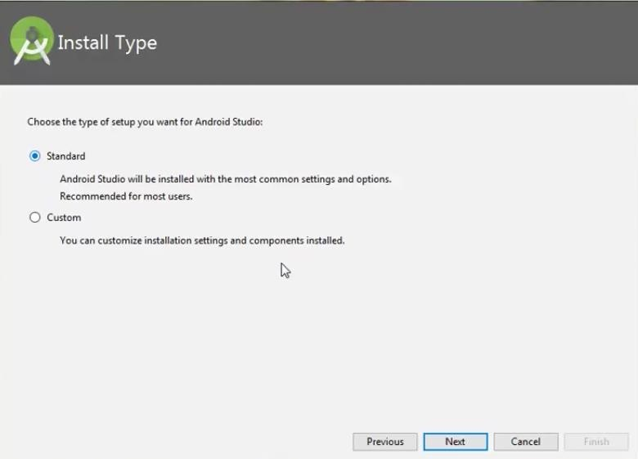

Choose Standard and click on Next.

Now choose the theme, whether Light theme or the Dark one .

The light one is called the IntelliJ theme whereas the dark theme is called Darcula . Choose as required.

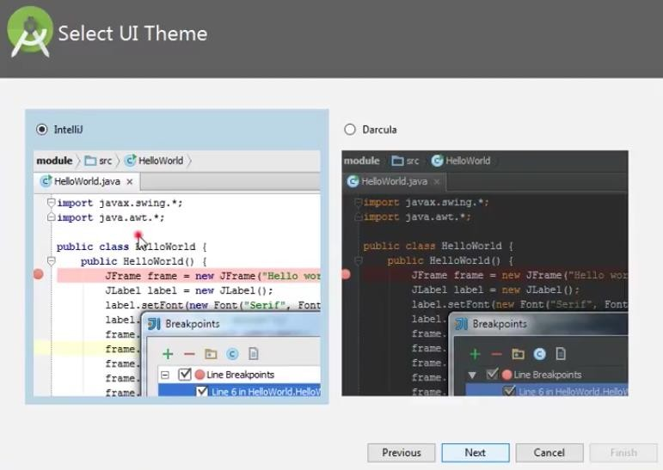

* Click on the Next button
* Step – 8 :

Now it is time to download the SDK components .

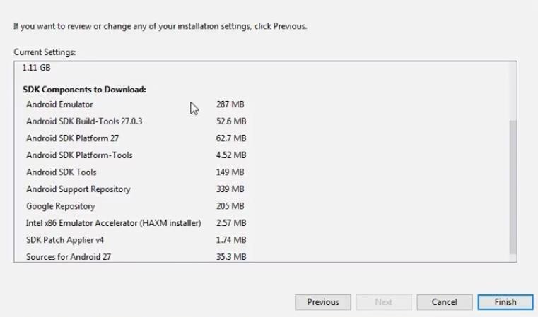

Click on Finish .

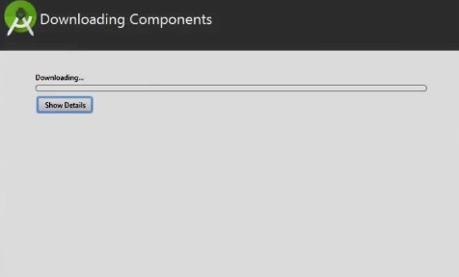

It has started downloading the components

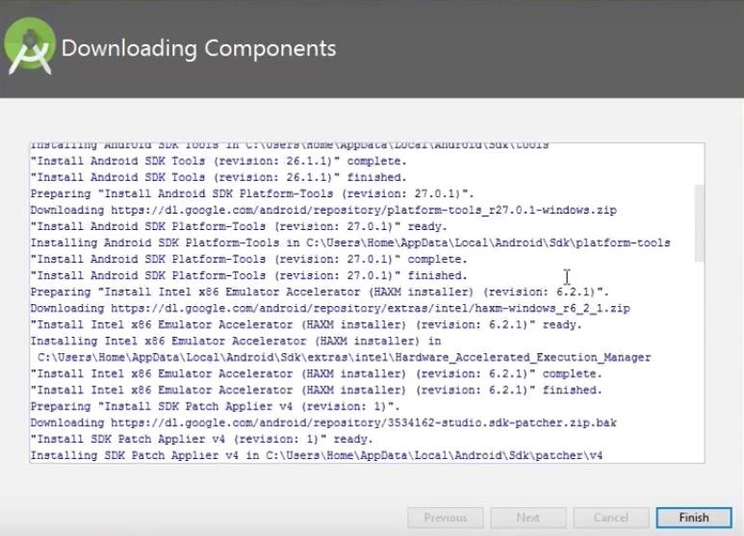

The Android Studio has been successfully configured. Now it’s time to launch and build apps.

# Steps to create a project in android

To create your new Android project, follow these steps:

* + Install the latest version of [Android Studio](https://developer.android.com/studio/).
  + In the Welcome to Android Studio window, click Start a new Android Studio project.

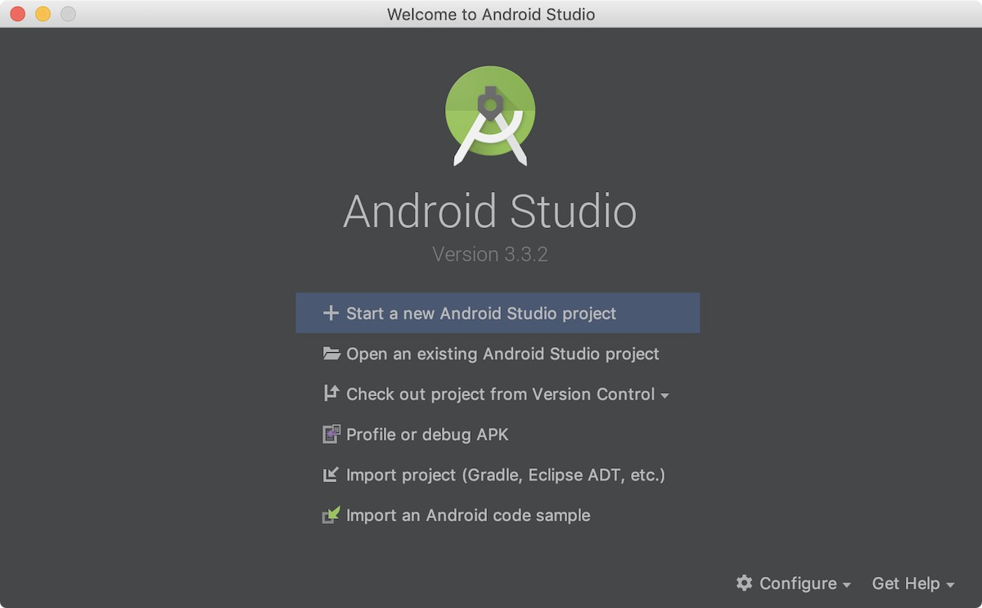

* + If you have a project already opened, select File > New > New Project.
  + In the Choose your project window, select Empty Activity and click Next.
  + In the Configure your project window, complete the following:
    1. Enter "My First App" in the Name field.
    2. Enter "com.example.myfirstapp" in the Package name field.
    3. If you'd like to place the project in a different folder, change its Save location.
    4. Select either Java or Kotlin from the Language drop-down menu.
  + Select the checkbox next to Use androidx.* artifacts.
  + Leave the other options as they are.
    1. **Sc(I.T) SEM-VI Maharashtra College Advanced Mobile Programming**
       - Click Finish.

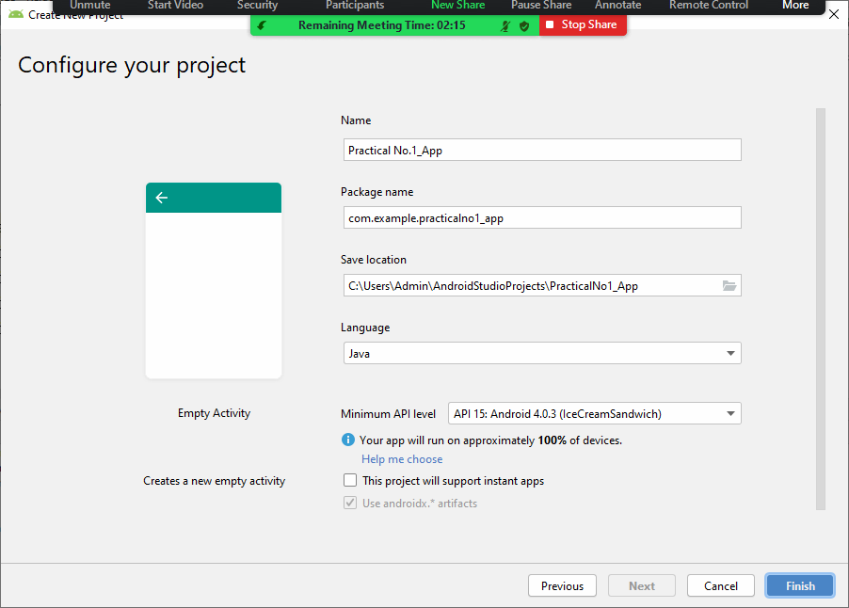

* + - * After some processing time, the Android Studio main window appears.

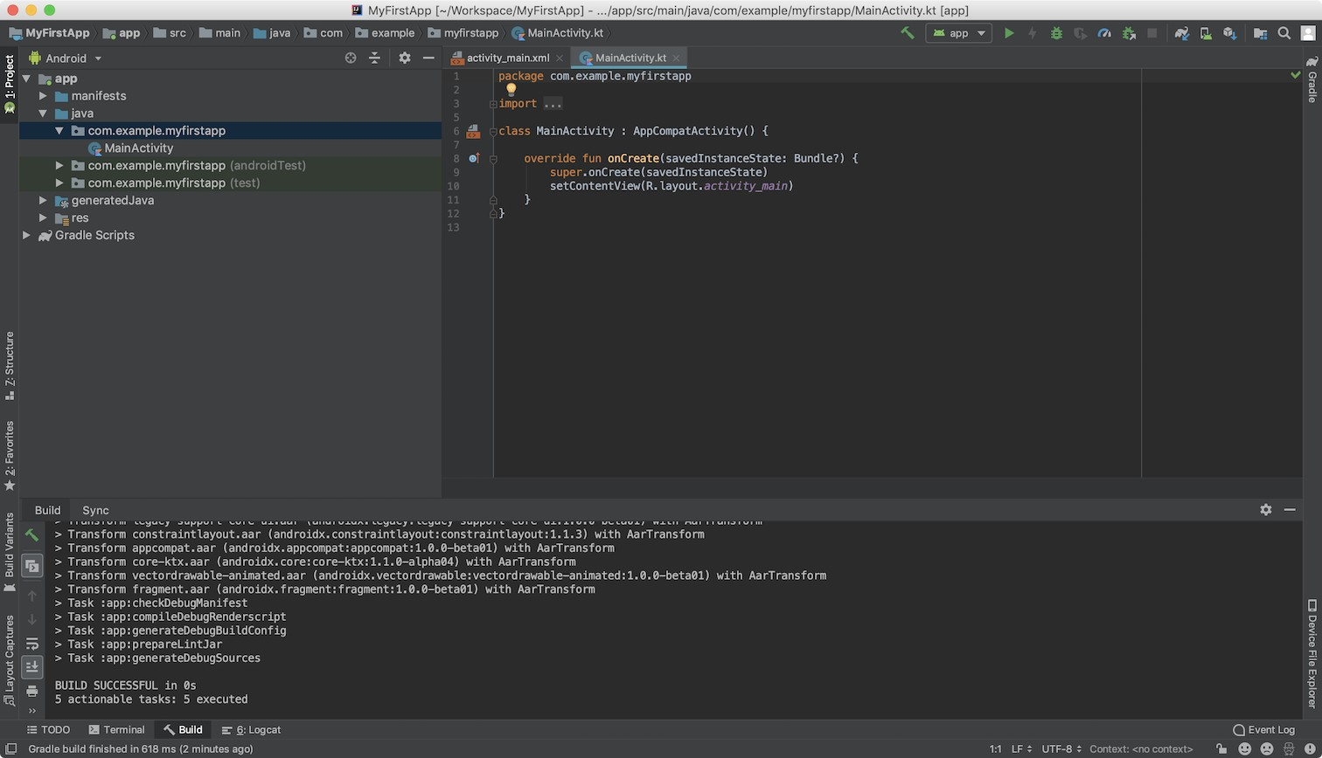

Note

To Open Project Window

select View > Tool Windows > Project To Open MainActivity.java file

app > java > PackageName > MainActivity.java To Open Layout activity_main.xml file

app > res > layout > activity_main.xml

## After the project is created, there are 2 files, **MainActivity.java and activity_main.xml**

1. Go to activity_main.xml and select **Design View**
2. In Design View, change the layout to **LinearLayout(Vertical)** select

**Add TextView,** and change the text to “Hello World!”

1. Click on **Run** and select the AVD already created(if not created, first create the AVD)
2. Output screen should show “Hello World”

**To create a new AVD:**

### Open the **AVD** Manager by clicking Tools > **AVD** Manager.

1. Click **Create Virtual Device**, at the bottom of the **AVD** Manager dialog. ...

### Select a hardware profile, and then click Next.

1. Select the system image for a particular API level, and then click Next.
2. Change **AVD** properties as needed, and then click Finish.

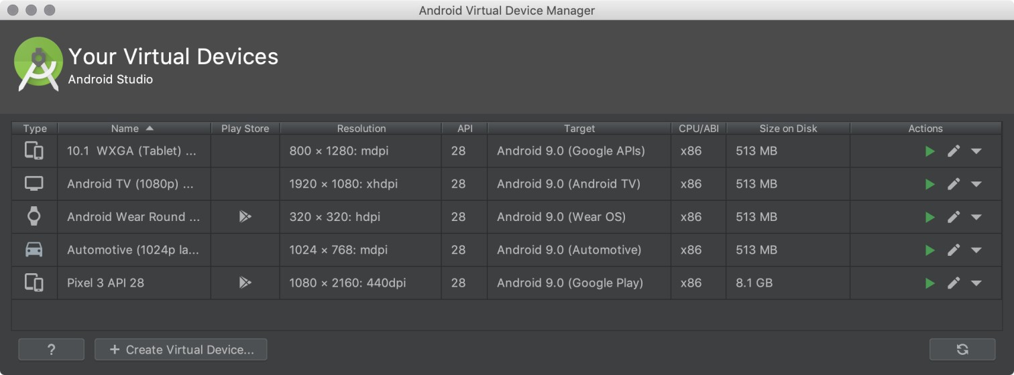

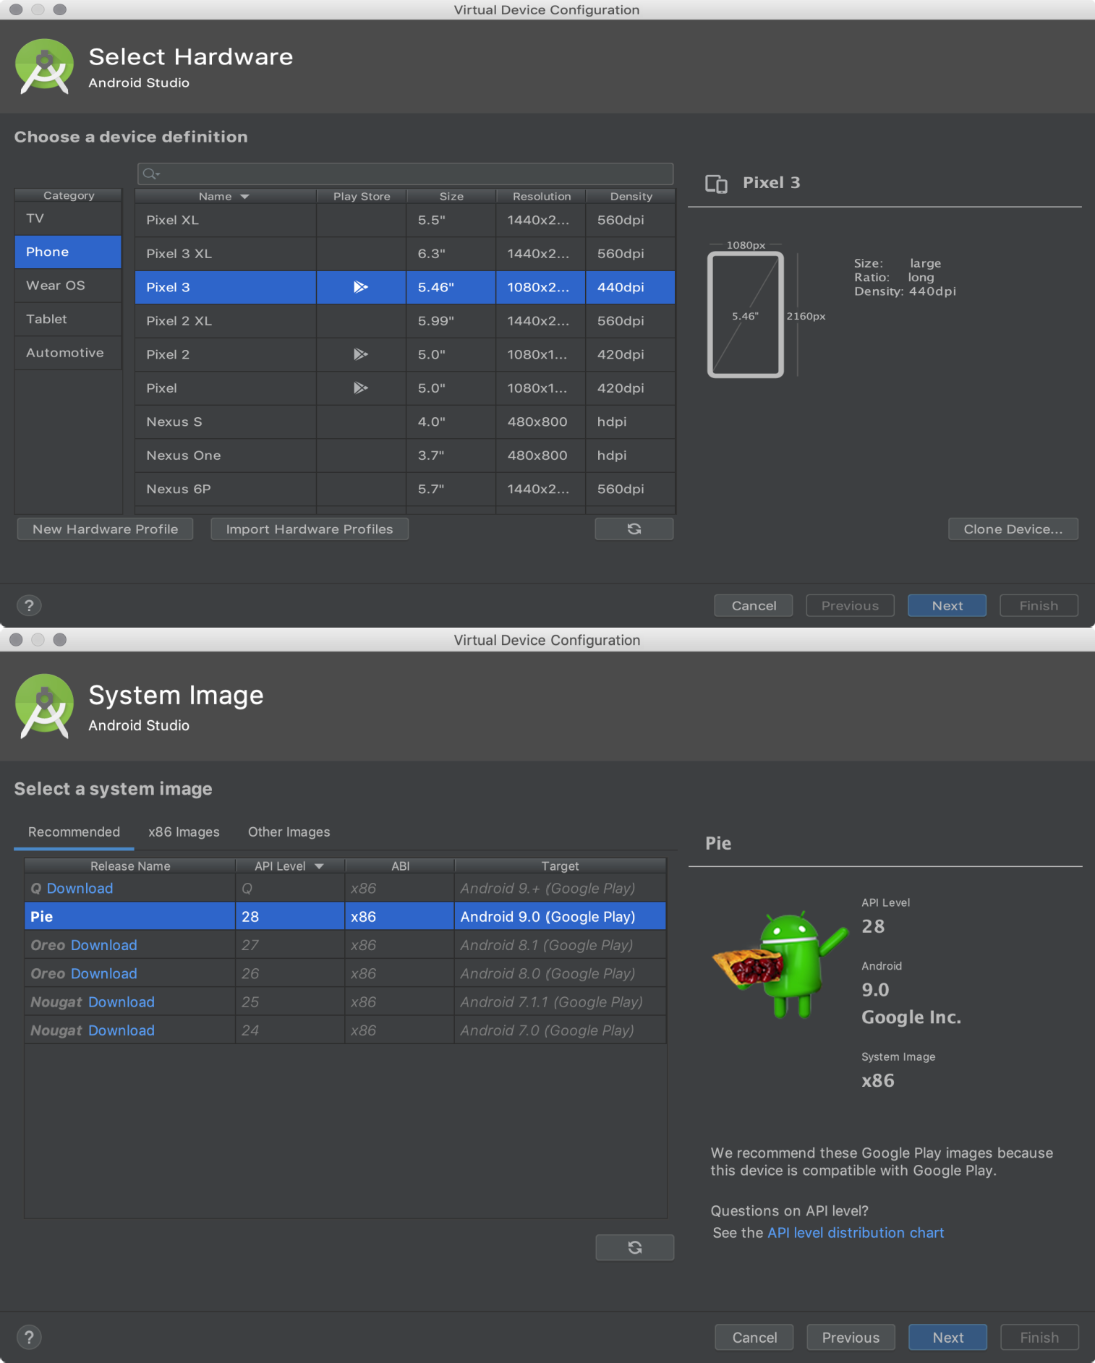

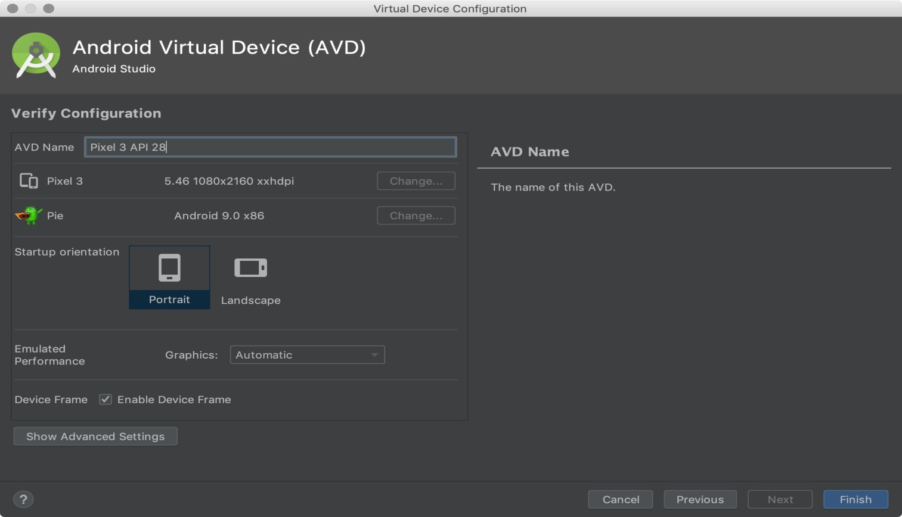

**Output**

